Practical 12 — Event Management CRUD and Poster Upload
Aim
To manage events with full CRUD plus validated poster image uploads stored with safe filenames.

Theory
Uploads are untrusted input: type, size and content must be verified on the server, files renamed unpredictably, and the upload folder blocked from executing scripts.
- Event fields cover title, description, date, location and category with the same validation discipline as students.
- Posters accept genuine images only: server-side content sniffing plus image parsing, a twomegabyte cap, random filenames and a folder guard blocking script execution.
- Rejected files — wrong type, renamed scripts, oversized images — are refused with friendly messages and nothing is stored.
- Deleting an event with dependent registrations is blocked to protect referential integrity.
- A dedicated migration documents the event-side changes for this practical.

Procedure
- Built the event-management page of about 35 KB with add, edit, delete, search and poster controls.
- Implemented server validation of fields and posters with content checks, size cap, random naming and folder protection.
- Added the event migration and kept uploads guarded.
- Inspected the management page, migration and upload guard on disk; live upload trials were not re-run here without a server.

Screenshots
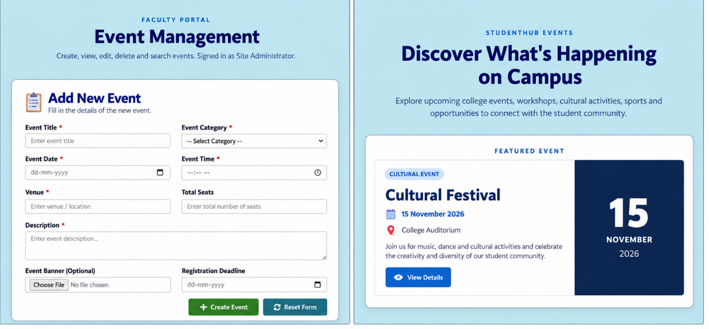

GitHub Repository Link
Practical repository : https://github.com/Rkpatel34/StudentHub/tree/main/studenthub

Conclusion
Practical 12 added media handling without opening script-execution or oversized-file holes.

